Installing MySQL on Windows
we are installing the latest version of MySQL (8.0.34) on Windows 11. Follow the given steps to do so −
Step 1: Firstly, choose the MySQL version and operating system. Then, we download the desired MSI installer on your system by clicking the 'Download' button shown in the image below. This installer is suitable for both 32-bit and 64-bit systems.
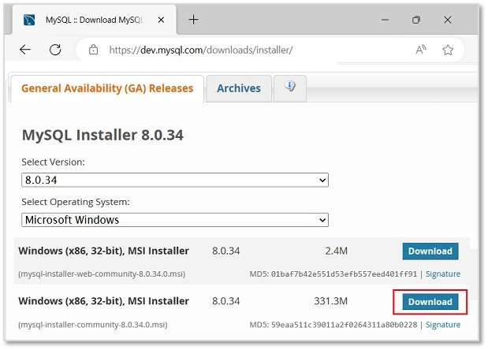
Step 2: Then, we will be redirected to another file download page. Here, ignore the prompts asking to log in or sign up and directly start downloading by clicking on the link as shown in the image.
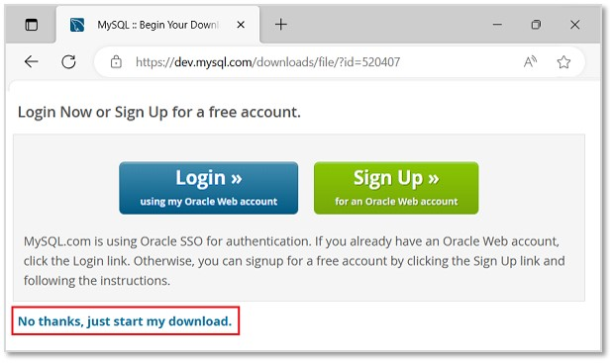
Step 3: Once the installer is downloaded, run it to start the MySQL installation.
Step 4: Now, we can see the installer community window, asking to choose a Setup type for our MySQL products. Choose Custom and click Next to decide what products we want to actually install.
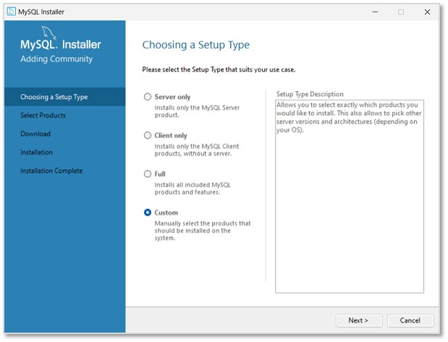
Step 5: In the next step, select MySQL Server, MySQL Workbench, MySQL Shell (all latest versions) to be installed. We can also choose more products available as per necessity. Click Next.
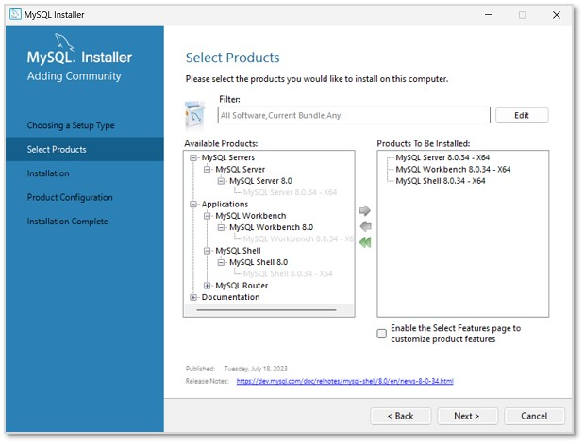
Step 6: The installation process will now begin. However, path conflicts might arise if there exists a path directory with the same name. After the installation is done, click Next.
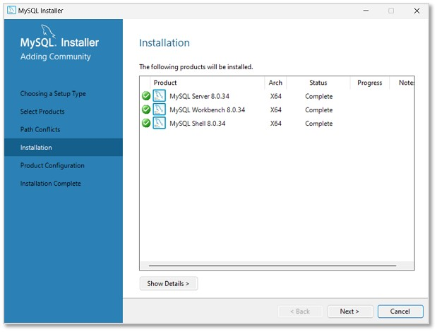
Step 7: In this step, we will be asked to set Type and Networking of MySQL. Unless there is any particular change we want to make, it is recommended to keep the settings as they are, and click Next.

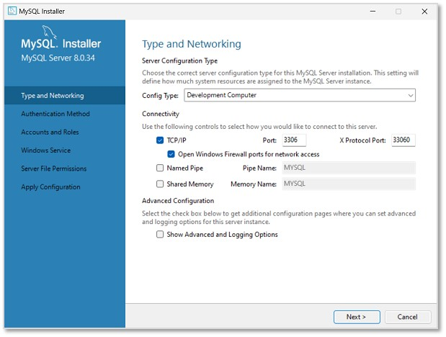
Step 8: Then, we need to set the Authentication method to access MySQL root user. So, choose the strong password encryption method (as it is recommended) and click Next.
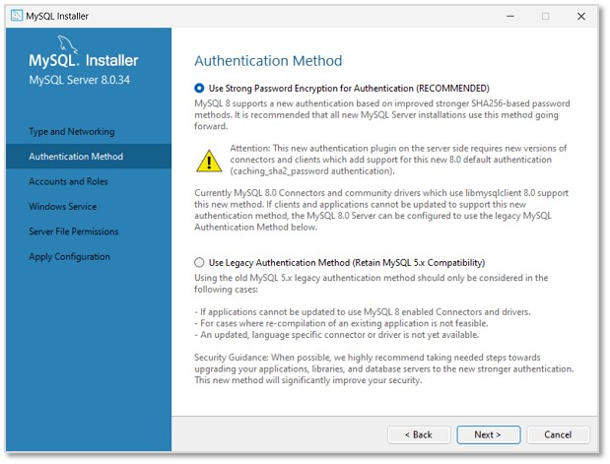
Step 9: Set a password for the root account. This password must always be used to log into the root account in every session. After setting password, click Next.
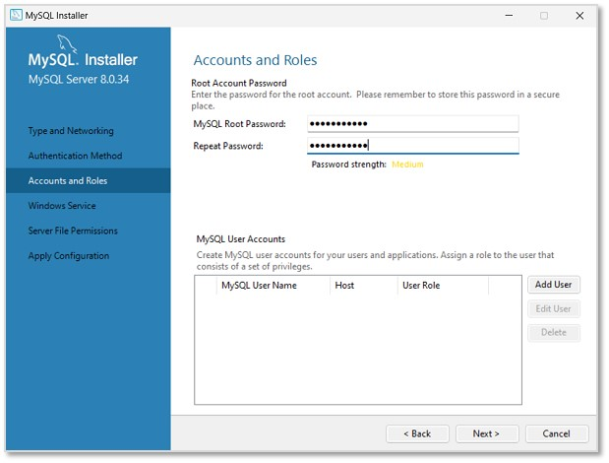
Step 10: In this step, MySQL Server Instance will be configured as a Windows Service. The default name will be set as "MySQL80", which can be changed if needed. Click Next.
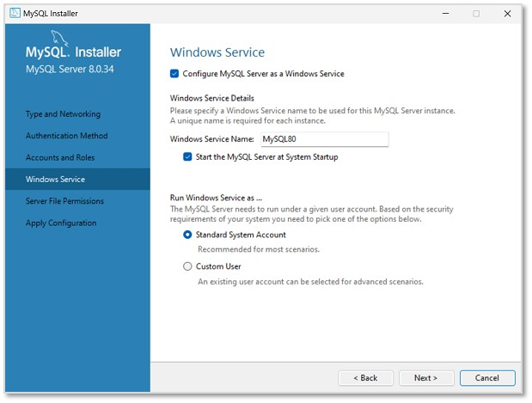
Step 11: Now, set the file permissions as required and click Next.
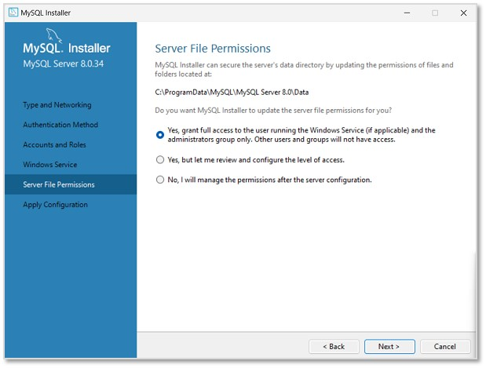
Step 12: As shown in the image below, the specified configuration steps will be applied on clicking Execute.
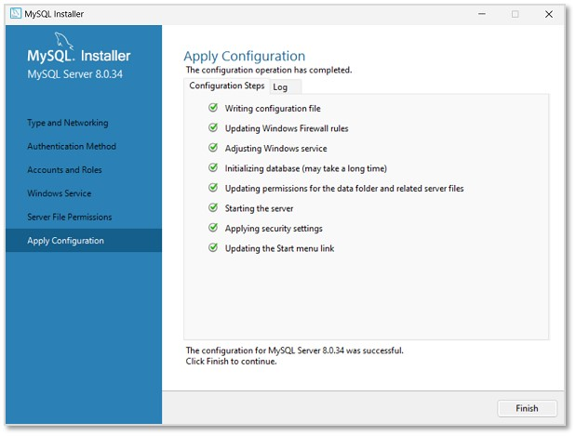
Once it is completed, click Finish. The next window will display the products on which the configuration is applied. Click Next to finish the installation.
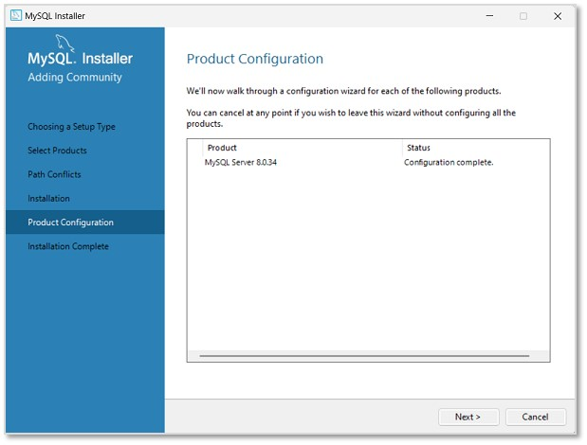
Step 12: The installation is now complete. Uncheck the options asking to start MySQL Workbench and Shell after setup, so that they will not run after setup. Click Finish.
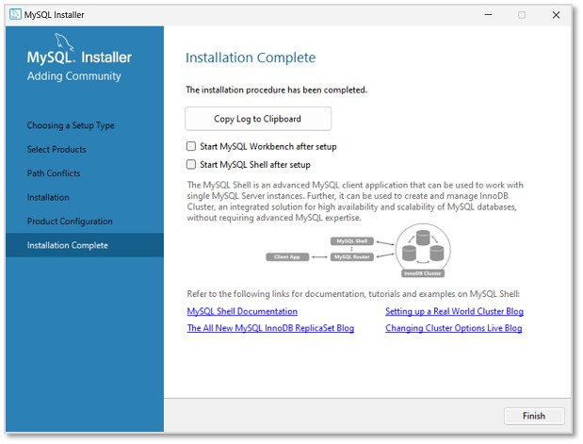
The MySQL Server is now installed in the Windows Operating System. We can now access it via the Command Prompt or the UI products we installed with it (Shell and Workbench).

SQL

SQL (Structured Query Language) is used to communicate with databases. It is used to store, retrieve, update and manage data.

Features :

Easy to learn and use

Standard language for databases

Powerful for data manipulation

Supports different types of databases

It is the language (like English)

MySQL

MySQL is an open-source Relational Database Management System (RDBMS) used to store, manage, retrieve, and manipulate structured data.

MySQL uses SQL (Structured Query Language) to communicate with the database.

SQL | MySQL
SQL = Structured Query Language | MySQL = Relational Database Management System (RDBMS)
It is a language. | It is software/database system.
It is used to communicate with databases. | It is used to store and manage databases.
SQL contains commands such as SELECT, INSERT, UPDATE, and DELETE. | MySQL understands and executes SQL commands.
SQL is not a database. | MySQL is a database management system.
Example: SELECT * FROM Student; | MySQL can execute this SQL query.

Data, Database, DBMS & RDBMS
1. What is Data?
Data is a collection of raw facts, numbers, names, or values that can be used to get useful information.
Examples
- Employee ID: 101
Data → Information
Example:
- Name: Rahul
- Age: 20
- Marks: 85
- City: Pune
- Employee ID: 101

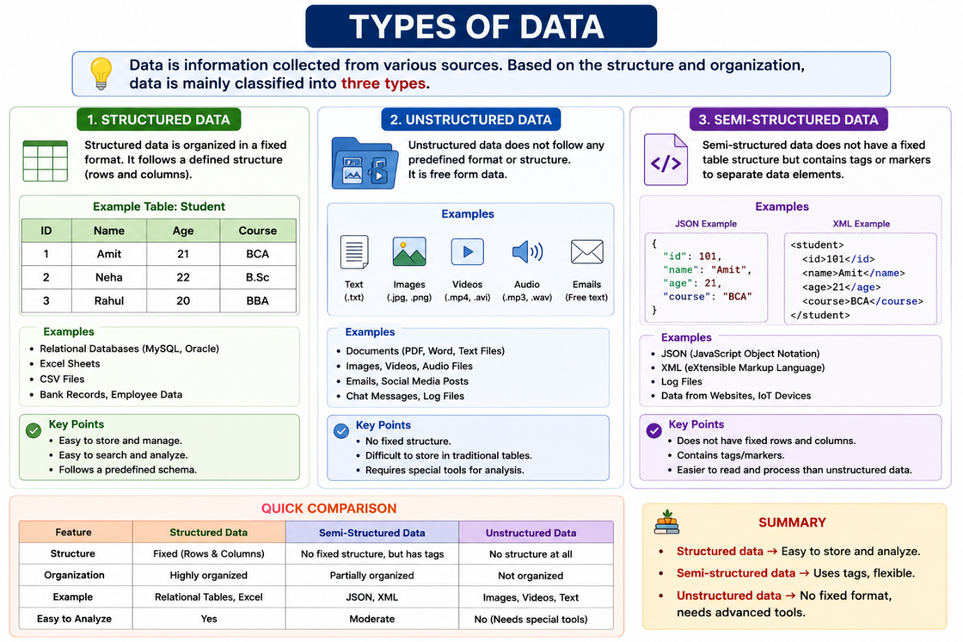
2. Types of Data
Data can be classified into different types.
A. Structured Data
Data that is organized in a fixed format, usually in rows and columns.
Example:
ID | Name | Age | City
101 | Rahul | 20 | Pune
102 | Priya | 21 | Mumbai
103 | Amit | 22 | Nashik

B. Unstructured Data
Data that does not have a fixed structure or predefined format.
Examples:
- Images
- Videos
- Audio
- Social media posts
- PDF documents
- Emails
UNSTRUCTURED DATA
│
├── Images
├── Videos
├── Audio
├── Documents
└── Emails

C. Semi-Structured Data
Semi-structured data is a combination of structured and unstructured data. It does not follow a fixed table structure like rows and columns, but it contains tags, keys, attributes, or metadata that give the data some organization.
Simple Example: Email
Email
│
├── From: rahul@gmail.com ← Structured
├── To: amit@gmail.com ← Structured
├── Date: 17-08-2026 ← Structured
├── Subject: Meeting ← Structured
│
└── Message:
"Hello Amit, let's meet
tomorrow at 10 AM." ← Unstructured
Here:
- From, To, Date, Subject → have a fixed format → Structured
- Message → can contain any text → Unstructured
- Both are present in the same email → Semi-Structured Data
Easy Way to Remember
Semi-Structured = Structured information + Unstructured content

Type | Structure | Examples
Structured | Fixed | SQL tables, Excel
Semi-structured | Partially organized | JSON, XML
Unstructured | No fixed structure | Images, videos, audio

3. What is a Database?
A database is an organized collection of related data that can be easily stored, accessed, managed, and updated.
SYNTAX
CREATE DATABASE database_name;
EXAMPLE
CREATE DATABASE CollegeDB;
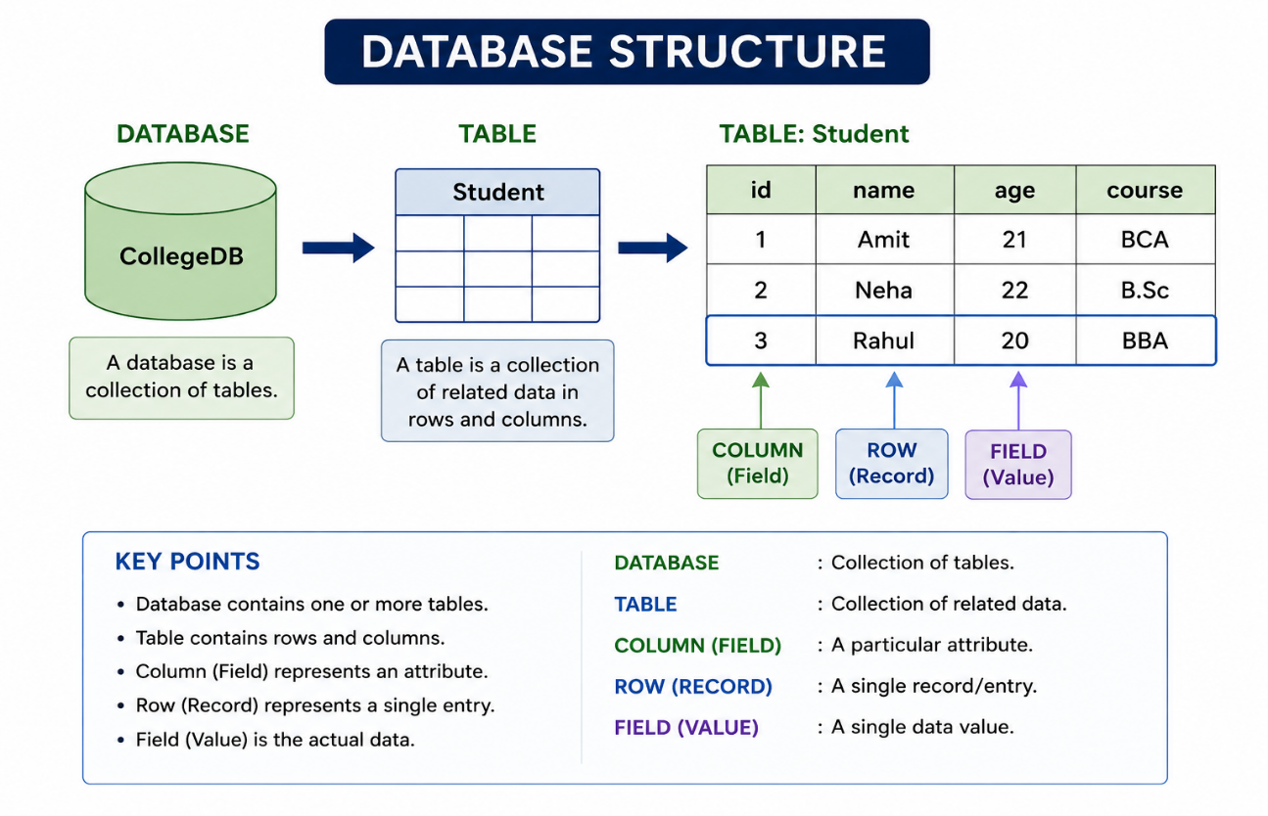
Student Table
Student_ID | Name | Age | Marks
101 | Rahul | 20 | 85
102 | Priya | 21 | 90
103 | Amit | 22 | 78
A database allows us to:
- Store data
- Search data
- Add new data
- Modify data
- Delete data
- Organize data
- Protect data

Data Type –
A data type defines what kind of data can be stored in a column of a database table.
Column | Data | Data Type
student_id | 101 | INT
student_name | Rahul | VARCHAR
age | 21 | INT
fees | 25000.50 | DECIMAL
birth_date | 2005-10-15 | DATE

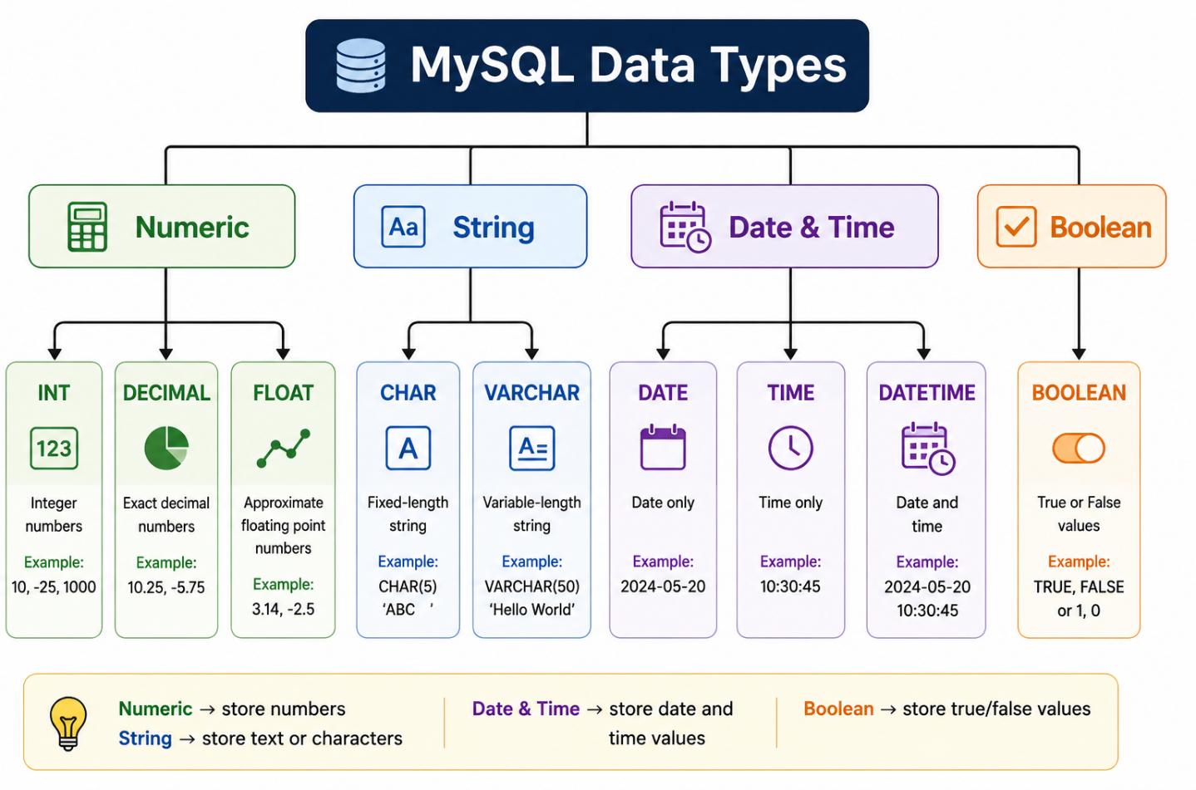

1 . Numeric Data Types –
Numeric data types are used to store numbers.
Common numeric types:
- INT
- DECIMAL
- FLOAT
- DOUBLE
1 INT -
INT stands for Integer.
It is used to store whole numbers, without decimal values.
CREATE TABLE student (student_id INT, age INT, marks INT);
2 DECIMAL -
DECIMAL is used for exact decimal numbers.
It is especially useful for:
- Price
- Salary
- Fees
- Purchase amount
- Bank balance
Syntax –
DECIMAL(M,D)
Where:
- M = total number of digits
- D = number of digits after the decimal point
Example -
DECIMAL(10,2)
This means:
- Maximum 10 digits in total
- 2 digits after the decimal point
CREATE TABLE product ( product_id INT, product_name VARCHAR(100), price DECIMAL(10,2));

product_id | product_name | price
1 | Laptop | 55000.50
2 | Mouse | 750.25
3 | Keyboard | 1200.00

DECIMAL is normally preferred because it stores exact decimal values.
3 FLOAT -
FLOAT stores floating-point numbers, which means numbers that can contain decimal values.
Example:
temperature FLOAT
CREATE TABLE weather ( temperature FLOAT);

String / Character Data Types
String data types are used to store text and characters.
Important types:
- CHAR
- VARCHAR
- TEXT
1 VARCHAR -
VARCHAR stands for Variable Character.
It is used to store text whose length can vary.
Syntax –
VARCHAR(size)
Example –
name VARCHAR(50)
Common uses
Use VARCHAR for:
- Names
- Cities
- Addresses
- Emails
- Phone numbers
- Course names
- Usernames
Why Phone Number Uses VARCHAR
Phone numbers contain numbers, so why don't we use INT?
Because a phone number is an identifier, not a number used for mathematical calculations.
For example:
0987654321
If treated as a numeric value, the leading 0 can be lost.
Phone numbers may also contain:
+91 9876543210

mobile VARCHAR(15)

Create Table –

CREATE TABLE student (student_id INT,student_name VARCHAR(50),
city VARCHAR(50), email VARCHAR(100),mobile VARCHAR(15));

Insert Values –
INSERT INTO student(student_id, student_name, city, email, mobile)
VALUES
(101, 'Rahul', 'Pune', 'rahul@gmail.com', '9876543210'),
(102, 'Priya', 'Mumbai', 'priya@gmail.com', '9876543211'),
(103, 'Amit', 'Delhi', 'amit@gmail.com', '9876543212');
Display the Data
SELECT * FROM student;

2 .CHAR -
CHAR stores a fixed-length string.
Syntax –
CHAR(size)
Example –
- gender CHAR(1)
Possible values:
M
F
- country_code CHAR(2)
IN
US
UK

Create Table
CREATE TABLE person ( person_id INT, person_name VARCHAR(50),gender CHAR(1),country_code CHAR(2));

Insert Values
INSERT INTO person (person_id, person_name, gender, country_code)
VALUES
(101, 'Rahul', 'M', 'IN'),
(102, 'Priya', 'F', 'IN'),
(103, 'John', 'M', 'US'),
(104, 'Emma', 'F', 'UK');
Display the Data
SELECT * FROM person;

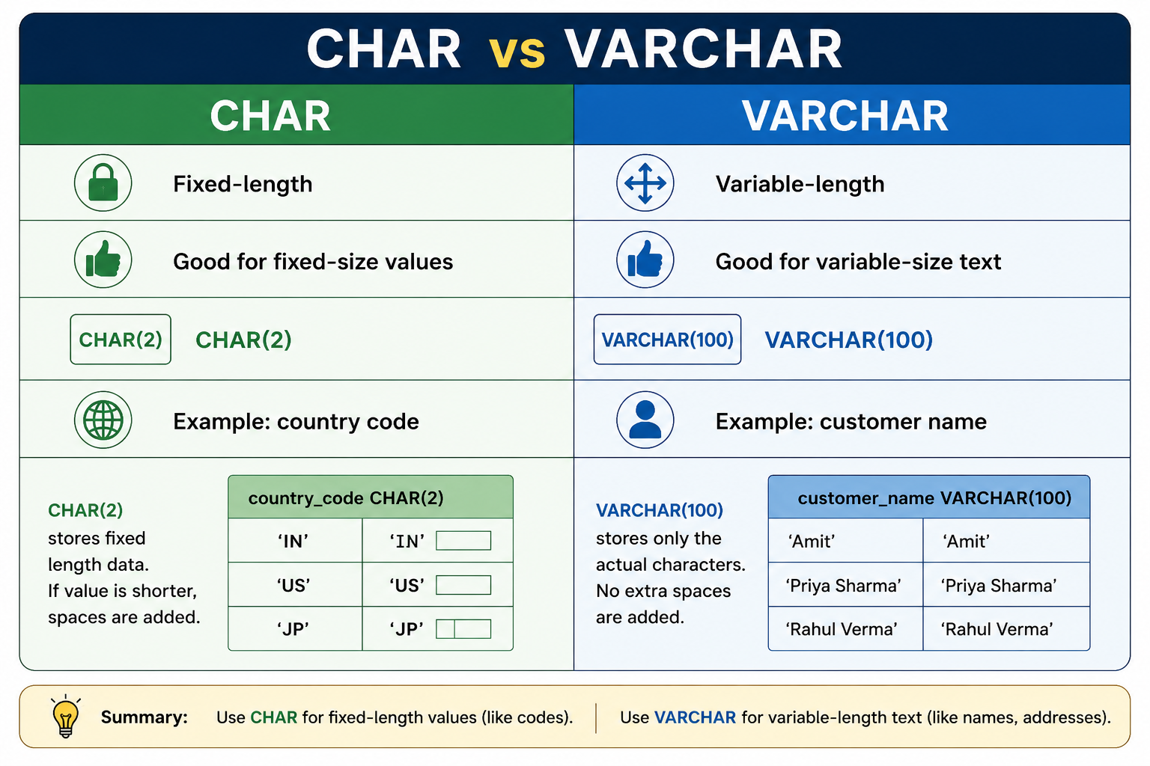

TEXT
TEXT is used for large amounts of text.
Example:
description TEXT
Useful for:
- Product descriptions
- Comments
- Reviews
- Feedback
- Long messages
Example –
CREATE TABLE feedback ( feedback_id INT, customer_name VARCHAR(100),
feedback TEXT);

1. Insert One Record -
INSERT INTO feedback (feedback_id, customer_name, feedback)
VALUES (1, 'Rahul', 'The service was very good.');

- Insert Multiple Records –
INSERT INTO feedback (feedback_id, customer_name, feedback)
VALUES
(1, 'Rahul', 'The service was very good.'),
(2, 'Priya', 'The product quality is excellent.'),
(3, 'Amit', 'Delivery was fast and convenient.'),
(4, 'Sneha', 'The service can be improved.');

⭐ Important -
For TEXT, write the text inside single quotes:
'The service was very good.'

DATE Data Type -
DATE stores a date.
The standard format is:
YYYY-MM-DD
Example:
registration_date DATE
CREATE TABLE customer (customer_id INT,customer_name VARCHAR(100),
registration_date DATE);

INSERT INTO customer (customer_id, customer_name, registration_date)
VALUES
(101, 'Rahul', '2026-01-10'),
(102, 'Priya', '2026-02-15'),
(103, 'Amit', '2026-03-20'),
(104, 'Sneha', '2026-04-05');

TIME –
TIME stores time.
Format:
HH:MM:SS
Example:
10:30:00
Example
login_time TIME
Possible value –
09:45:30

CREATE TABLE login_details (customer_id INT, customer_name VARCHAR(100), login_time TIME);

INSERT INTO login_details
(customer_id, customer_name, login_time)
VALUES
(101, 'Rahul', '09:45:30'),
(102, 'Priya', '10:30:00'),
(103, 'Amit', '14:15:20');

SELECT * FROM login_details;

DATETIME –

DATETIME stores both:
- Date
- Time
Syntax:
YYYY-MM-DD HH:MM:SS
Example:
2026-08-20 10:30:00
CREATE TABLE customer 1(customer_id INT, customer_name VARCHAR(100), registration_datetime DATETIME);

INSERT INTO customer1
(customer_id, customer_name, registration_datetime)
VALUES
(101, 'Rahul', '2026-08-20 10:30:00'),
(102, 'Priya', '2026-08-20 11:45:30'),
(103, 'Amit', '2026-08-21 09:15:00');

BOOLEAN -
BOOLEAN represents a logical value:
TRUE
FALSE
CREATE TABLE customer_status (customer_name VARCHAR(100),
is_active BOOLEAN);

INSERT INTO customer_status (customer_name, is_active)
VALUES('Rahul', TRUE),('Priya', FALSE);

SELECT * FROM customer_status;

4. What is DBMS?
DBMS = Database Management System
A DBMS is software used to create, store, manage, retrieve, update, and delete data in a database.
Examples of DBMS
- MySQL
- Oracle Database
- Microsoft Access
- PostgreSQL
- SQLite

5. Functions of DBMS
A DBMS performs many important operations.

Main Functions
- Data Storage – Stores data efficiently.
- Data Retrieval – Retrieves required data.
- Data Manipulation – Insert, update and delete data.
- Security – Controls access to data.
- Backup – Creates copies of data.
- Recovery – Restores data after failure.
- Concurrency Control – Allows multiple users to work with the database.
- Data Integrity – Maintains accuracy and consistency.

6. What is RDBMS?
RDBMS = Relational Database Management System
An RDBMS is a type of DBMS that stores data in the form of tables, where tables can be related to each other using keys.
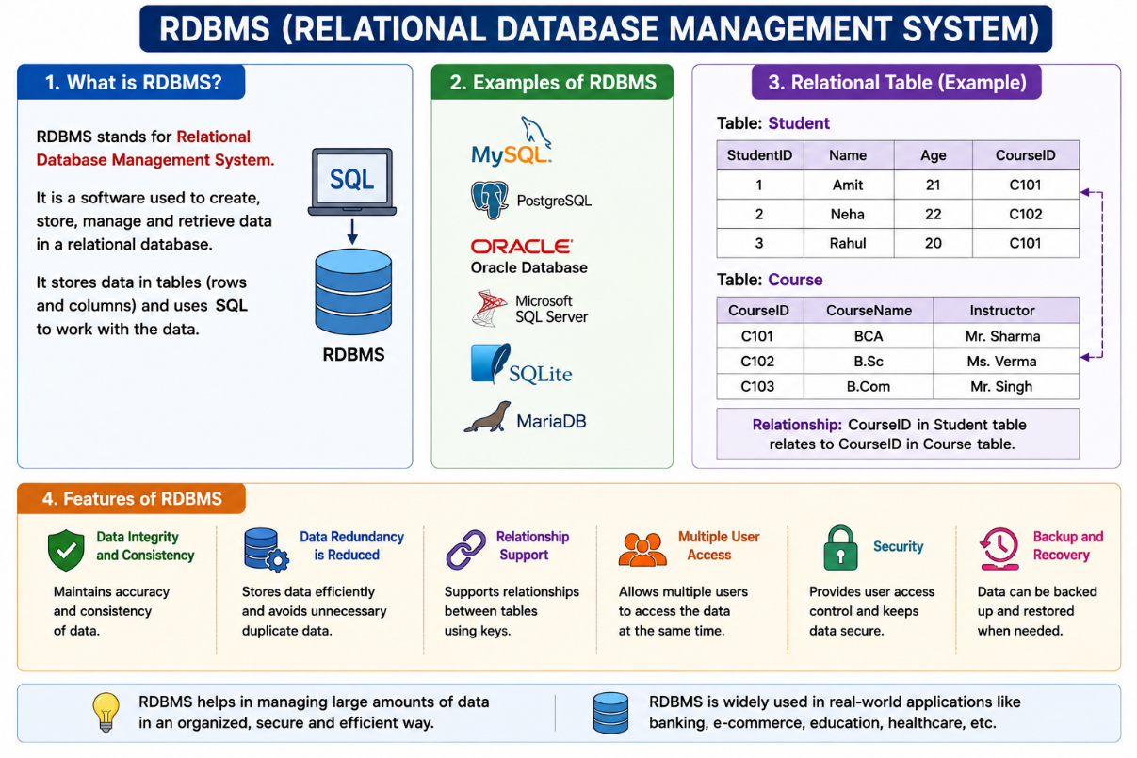
Example of RDBMS :-
- MYSQL
- POSTGRESQL
- ORACLE
- MICROSOFT
- MICROSOTF SQL SERVER
- SQLITE

Example
Student Table
Student_ID | Name | Course_ID
101 | Rahul | C01
102 | Priya | C02
Course Table
Course_ID | Course_Name
C01 | Python
C02 | Java
Here, Course_ID connects the two tables.
STUDENT TABLE COURSE TABLE
Student_ID |  | Name | Course_ID | Course_Name
101 | Rahul |  | C01 | Python
102 | Priya |  | C02 | Java

└──── Course_ID ──┘

7. DBMS vs RDBMS
DBMS | RDBMS
Database Management System | Relational Database Management System
May store data in different forms | Stores data mainly in tables
Relationships may not be required | Relationships between tables are important
May have limited constraints | Supports keys and constraints
Suitable for simpler applications | Suitable for large and complex applications
Example: some file-based DBMS | MySQL, Oracle, PostgreSQL

RDBMS — Relationship, Table, Tuple, Record & Attribute
1. Relationship
Definition
A relationship is a connection between two or more tables in a database.
In an RDBMS, relationships are usually created using Primary Key and Foreign Key.
Example
Suppose we have two tables:
Student Table
Student_ID | Name | Course_ID
101 | Rahul | C01
102 | Priya | C02
Course Table
Course_ID | Course_Name
C01 | Python
C02 | Java
Here, Course_ID connects the Student table with the Course table.
STUDENT TABLE COURSE TABLE

Student_ID | Course_ID
Name | Course_Name

Course_ID ───────────────────► Course_ID
Foreign Key Primary Key
Relationship is a connection between tables using common fields, usually Primary Key and Foreign Key.

2. Types of Relationships
There are three main types of relationships in an RDBMS.
A. One-to-One (1:1)
One record in one table is related to only one record in another table.
Example: Person and Passport
PERSON PASSPORT
1 ──────────────── 1
One person has one passport.

B. One-to-Many (1:N)
One record in one table can be related to many records in another table.
Example: Department and Employees
DEPARTMENT EMPLOYEE
1 MANY
│ │
└──────────────────────►
One department can have many employees.
Computer Department
│
├── Rahul
├── Priya
├── Amit
└── Sneha

C. Many-to-Many (M:M)
Many records in one table can be related to many records in another table.
Example: Students and Courses
STUDENTS ◄──────────────► COURSES
MANY MANY
One student can study multiple courses, and one course can have multiple students.
Usually, an intermediate table is used:
STUDENT
│
▼
ENROLLMENT
│
▼
COURSE

3. Table Structure
A table consists of:
- Table name
- Columns
- Rows
- Fields
- Records

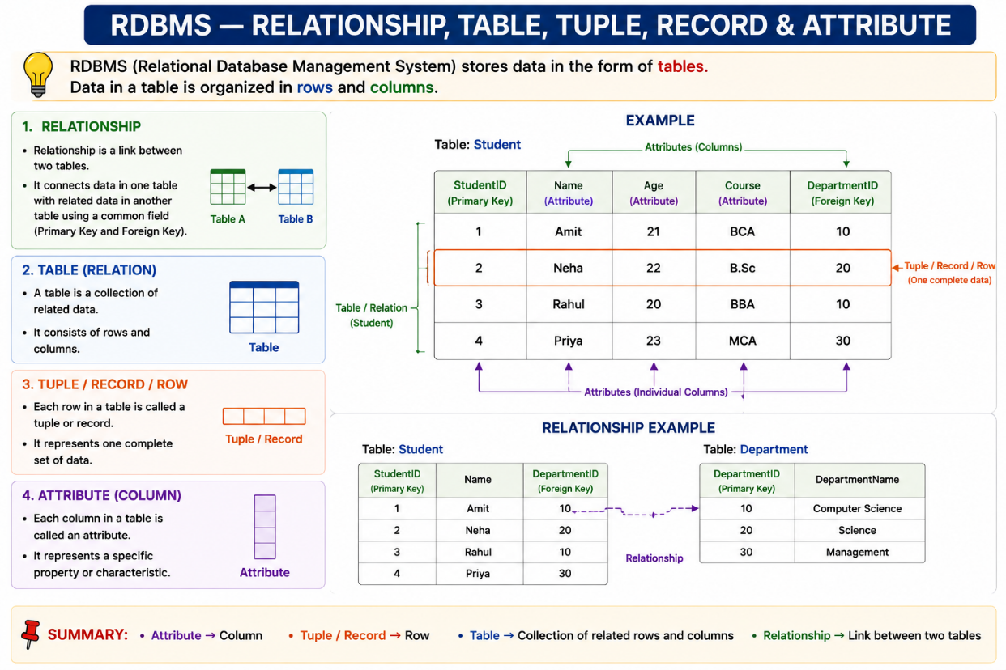

Example: Student Table
Student_ID | Name | Age | City
101 | Rahul | 20 | Pune
102 | Priya | 21 | Mumbai
103 | Amit | 22 | Nashik

STUDENT TABLE
│
┌──────────────┼──────────────┐
▼ ▼ ▼
Columns Rows Records
(Attributes)

4. Attribute
An attribute is a property or characteristic of an entity.
In a relational table, an attribute is represented by a column.
Example:
Student_ID | Name | Age | City
101 | Rahul | 20 | Pune
The attributes are:
- Student_ID
- Name
- Age
- City

Table Structure
A table is used to store data in the form of rows and columns.
Example: Student Table
Student_ID | Name | Age | City
101 | Rahul | 20 | Pune
102 | Priya | 21 | Mumbai
103 | Amit | 22 | Nashik
Definitions from the same table
Term | Simple Definition | Example
Table Name | Name given to the table. | Student
Column | Vertical part of a table that represents an attribute. | Name
Field | A column that stores a particular type of data. | Age
Row | Horizontal line containing one complete set of data. | 101, Rahul, 20, Pune
Record | Complete information about one person/item in a row. | Rahul's complete information

Table = Collection of rows and columns
Column = Attribute / Field
Row = Record / Tuple
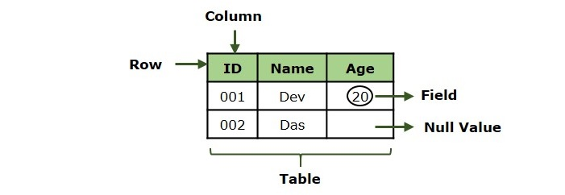
SQL Commands /Statement/Subset:-
SQL commands are instructions used to create, manage, retrieve, and control data in a database.
DDL - | Data Definition Language
DML - | Data Manipulation Language
DQL - | Data Query Language
DCL - | Data Control Language
TCL - | Transaction Control Language

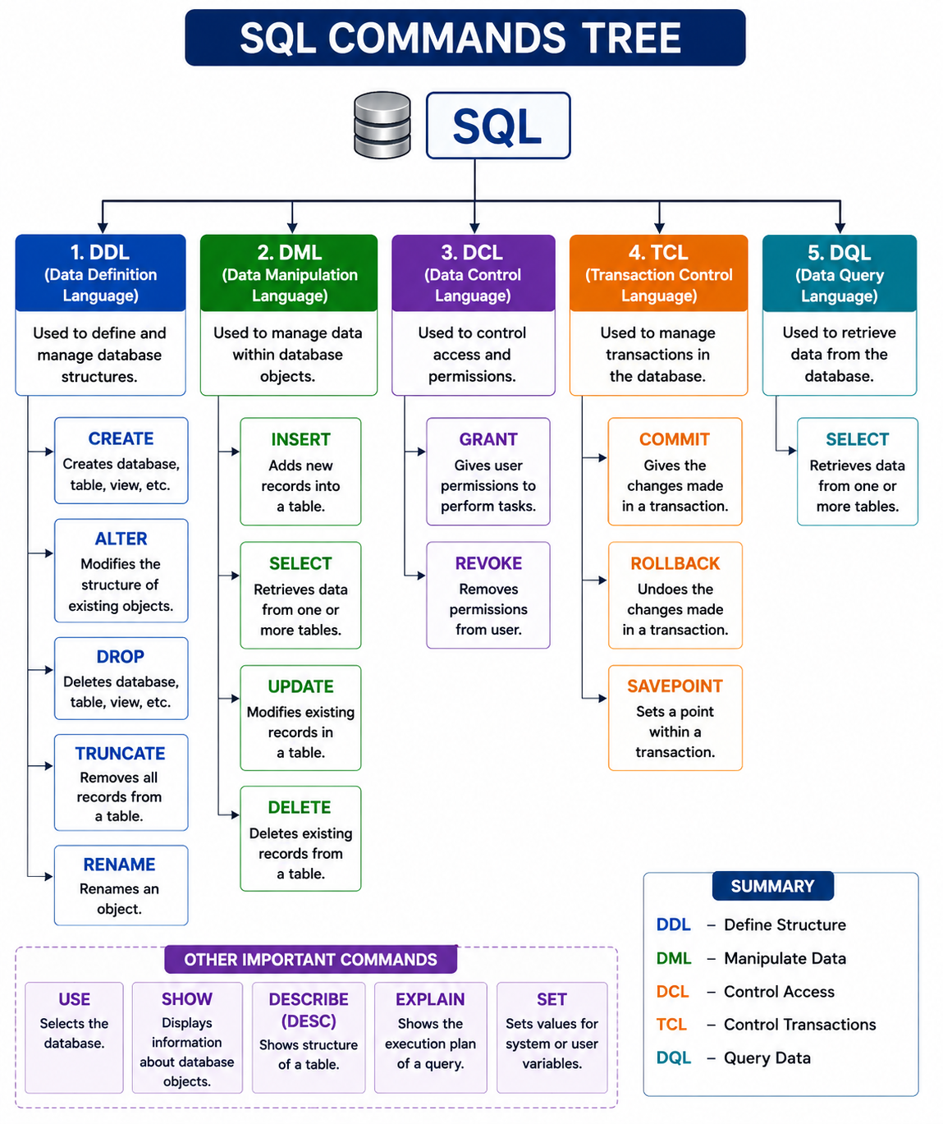

1 . DDL — Data Definition Language :-
DDL commands are used to create, modify, and remove the structure of database objects.
Create, Alter, Drop, Truncate, Rename, Explain, Describe
1 . CREATE —
The CREATE command is used to create new database objects such as databases and tables.
A .CREATE DATABASE -
Syntax:-
CREATE DATABASE database_name;
Example:-
CREATE DATABASE company;
USE company;

B. CREATE TABLE -
The CREATE TABLE command is used to create a new table.
Syntax :-
CREATE TABLE table_name ( column1 datatype,column2 datatype,column3 datatype);
Example:-
CREATE TABLE students (student_id int,name varchar(100),age int, course varchar(50));

# View the table structure :-
A .DESCRIBE -
DESC students;
DESCRIBE students;
B . EXPLAIN –
Syntax -
Explain table_name;
Explain select * from table_name;
Example –
Explain student;
Explain select * from student;

2 . ALTER Command :-
The ALTER command is used to modify the structure of an existing table.
You can use ALTER TABLE to:
- Add a column
- Modify a column's data type
- Rename a column
- Drop a column
1. Add a New Column
A. Add Single column:-
Syntax-

ALTER TABLE table_name ADD column_name datatype;
Example –
ALTER TABLE students ADD email VARCHAR(100);
Syntax :-
ALTER TABLE table_name ADD column_name datatype AFTER existing_column;
Example :-
alter table emp2 add column location varchar(20) after job;

B. Add Multiple Columns :-
Syntax -
ALTER TABLE table_name ADD column1 datatype, ADD column2 datatype;
Example –
ALTER TABLE students ADD phone VARCHAR(15), ADD city VARCHAR(50);

2. MODIFY -
MODIFY is used in MySQL to change the data type or definition of an existing column.
Syntax –
ALTER TABLE table_name MODIFY column_name new_datatype;
Example –
ALTER TABLE students MODIFY name VARCHAR(150);
ALTER TABLE employees MODIFY salary DECIMAL(12,2);

3 . RENAME a Column -
MySQL provides CHANGE and RENAME COLUMN for renaming columns.
Syntax –
ALTER TABLE table_name RENAME COLUMN old_column_name TO new_column_name;

Example –
ALTER TABLE students RENAME COLUMN name TO full_name;

4 . DROP Column –
DROP COLUMN is used to permanently remove a column from a table.
Syntax –
ALTER TABLE table_name DROP COLUMN column_name;
Example –
ALTER TABLE students DROP COLUMN email;

3.DROP -
1 . DROP TABLE :-
The DROP TABLE command is used to permanently delete an entire table.
Syntax –
DROP TABLE table_name;
Example –
DROP TABLE students;
2. DROP DATABASE
DROP DATABASE removes an entire database.
Syntax –
DROP DATABASE database_name;
Example-
DROP DATABASE college;

4 . TRUNCATE Command –
TRUNCATE removes all rows from a table, but keeps the table structure.
Syntax –
TRUNCATE TABLE table_name;
Example-
TRUNCATE TABLE students;

5 . RENAME TABLE -
The RENAME command can be used to change the name of a table.
Syntax –
RENAME TABLE old_table_name TO new_table_name;
Example-
RENAME TABLE students TO college_students;

2 . DML — Data Manipulation Language :-
DML (Data Manipulation Language) is a part of SQL used to insert, retrieve, modify, and delete data stored inside tables.
While DDL deals with the structure of a table, DML deals with the records/rows inside the table.
Insert ,Update,Delete

1 . INSERT Command -
The INSERT command is used to add new records/rows to a table.
A. INSERT values into all columns :-
Syntax –
INSERT INTO table_name VALUES (value1, value2, value3, ...);
Example-
INSERT INTO students VALUES (1, 'Rahul', 20, 'Python');
B. INSERT with Column Names :-
It is generally better to specify the column names explicitly.
Syntax –
INSERT INTO table_name(column1, column2, column3) VALUES (value1, value2, value3);
Example-
INSERT INTO students(student_id, name, age, course)VALUES
(2, 'Priya', 21, 'Java');

C . INSERT Multiple Records :-
You can insert multiple rows using a single INSERT statement.
Syntax –
INSERT INTO table_name(column1, column2, column3)
VALUES(value1, value2, value3),
(value1, value2, value3),
(value1, value2, value3);
Example-
INSERT INTO students(student_id, name, age, course)
VALUES
(3, 'Amit', 19, 'C++'),
(4, 'Sneha', 20, 'Python'),
(5, 'Rohan', 22, 'Java');
D. INSERT NULL Value
NULL means no value / unknown value.
Example –
INSERT INTO students(student_id, name, age, course)VALUES
(6, 'Neha', NULL, 'Python');

2. UPDATE Command -
The UPDATE command is used to modify existing records.
A. UPDATE Multiple Columns :-
Syntax
UPDATE table_name
SET column_name = new_value
WHERE condition;
Example –
UPDATE students
SET age = 21
WHERE student_id = 1;
SQL UPDATE Salary Questions – 5%, 10% and 20%
Based on your emp table, here are practical UPDATE questions with answers and explanations.
Important: Salary Percentage Formula
Percentage | Formula
5% increase | sal = sal * 1.05
10% increase | sal = sal * 1.10
20% increase | sal = sal * 1.20
You can also write:
SET sal = sal + (sal * 10 / 100);

1. Increase all employees' salary by 10%
Answer:
UPDATE emp
SET sal = sal * 1.10;
Explanation:
- UPDATE emp → Updates the emp table.
- SET sal = → Changes the salary column.
- sal * 1.10 → Keeps the original salary and adds 10%.
Example:
SMITH's salary:
800 + 10% = 880

2. Increase all employees' salary by 20%
Answer:
UPDATE emp
SET sal = sal * 1.20;
Explanation:
20% means:
Original Salary + 20% of Original Salary
Example:
800 × 1.20 = 960

3. Increase all employees' salary by 5%
Answer:
UPDATE emp
SET sal = sal * 1.05;
Example:
SMITH:
800 × 1.05 = 840

4. Increase salary by 10% for CLERK employees
Answer:
UPDATE emp
SET sal = sal * 1.10
WHERE job = 'CLERK';
Explanation:
Only employees whose job is CLERK will get a 10% salary increase.
Affected employees:
- SMITH
- ADAMS
- JAMES
- MILLER

5. Increase salary by 20% for MANAGER employees
Answer:
UPDATE emp
SET sal = sal * 1.20
WHERE job = 'MANAGER';
Affected Employees:
- JONES
- BLAKE
- CLARK
Example:
JONES:
2975 × 1.20 = 3570

6. Increase salary by 5% for SALESMAN employees
Answer:
UPDATE emp
SET sal = sal * 1.05
WHERE job = 'SALESMAN';
Affected Employees:
- ALLEN
- WARD
- MARTIN
- TURNER
Example:
ALLEN:
1600 × 1.05 = 1680

7. Increase salary by 10% for employees in department 20
Answer:
UPDATE emp
SET sal = sal * 1.10
WHERE deptno = 20;
Explanation:
Only employees working in department number 20 will receive a 10% increase.

8. Increase salary by 20% for employees in department 30
Answer:
UPDATE emp
SET sal = sal * 1.20
WHERE deptno = 30;
Explanation:
Only department 30 employees will be updated.

9. Increase salary by 5% for employees whose salary is less than 2000
Answer:
UPDATE emp
SET sal = sal * 1.05
WHERE sal < 2000;
Employees affected:
- SMITH
- ALLEN
- WARD
- MARTIN
- TURNER
- ADAMS
- JAMES
- MILLER

10. Increase salary by 10% for employees whose salary is greater than 3000
Answer:
UPDATE emp
SET sal = sal * 1.10
WHERE sal > 3000;
Explanation:
Only employees having salary greater than 3000 will get the increment.
From your current table:
- KING → 5000

11. Increase salary by 20% for employees hired before 1982
Answer:
UPDATE emp
SET sal = sal * 1.20
WHERE hire < '1982-01-01';
Explanation:
Employees hired before January 1, 1982 will get a 20% salary increase.

12. Increase salary by 5% for employees whose name starts with 'A'
Answer:
UPDATE emp
SET sal = sal * 1.05
WHERE ename LIKE 'A%';
Affected Employees:
- ALLEN
- ADAMS

13. Increase salary by 10% for ANALYST employees
Answer:
UPDATE emp
SET sal = sal * 1.10
WHERE job = 'ANALYST';
Affected Employees:
- SCOTT
- FORD

14. Increase salary by 20% for employees having NULL commission
Answer:
UPDATE emp
SET sal = sal * 1.20
WHERE comm IS NULL;
Important:
For NULL, we use:
IS NULL
❌ Wrong:
WHERE comm = NULL;
✅ Correct:
WHERE comm IS NULL;

15. Increase salary by 5% for employees earning between 1000 and 3000
Answer:
UPDATE emp
SET sal = sal * 1.05
WHERE sal BETWEEN 1000 AND 3000;
Explanation:
BETWEEN includes both values:
1000 ≤ Salary ≤ 3000

16. Increase salary by 10% for department 10 and 20
Answer:
UPDATE emp
SET sal = sal * 1.10
WHERE deptno IN (10, 20);
Explanation:
IN is used when we want to check multiple values.

17. Increase salary by 20% for SALESMAN employees in department 30
Answer:
UPDATE emp
SET sal = sal * 1.20
WHERE job = 'SALESMAN'
AND deptno = 30;
Explanation:
Both conditions must be true:
- Job must be SALESMAN.
- Department must be 30.

18. Increase salary by 5% for employees earning more than 2000 in department 20
Answer:
UPDATE emp
SET sal = sal * 1.05
WHERE sal > 2000
AND deptno = 20;

19. Increase salary by 10% for employees except PRESIDENT
Answer:
UPDATE emp
SET sal = sal * 1.10
WHERE job != 'PRESIDENT';
Explanation:
All employees except KING will receive a 10% salary increase.

20. Increase salary by 20% for employees whose commission is greater than 500
Answer:
UPDATE emp
SET sal = sal * 1.20
WHERE comm > 500;
Based on your table:
MARTIN has:
Commission = 1400
So MARTIN will be updated.

Important SELECT Query Before UPDATE
Before executing an UPDATE query, students should first check the records using SELECT.
Example:
SELECT *
FROM emp
WHERE job = 'CLERK';
Then update:
UPDATE emp
SET sal = sal * 1.10
WHERE job = 'CLERK';
Finally check:
SELECT *
FROM emp
WHERE job = 'CLERK';

Best Formula for Students to Remember
5% Increase → sal * 1.05

10% Increase → sal * 1.10

20% Increase → sal * 1.20
Alternative Formula:
-- 5%
SET sal = sal + (sal * 5 / 100);

-- 10%
SET sal = sal + (sal * 10 / 100);

-- 20%
SET sal = sal + (sal * 20 / 100);
Practice Tip
⚠️ UPDATE permanently changes the data. For practice, always run the SELECT query first to check which records will be affected.

B. UPDATE Multiple Columns :-
You can modify multiple columns in a single statement.
Syntax :-
UPDATE table_name
SET column1 = value1,
column2 = value2
WHERE condition;
Example –
UPDATE students
SET age = 22,
course = 'Java'
WHERE student_id = 1;

C . UPDATE Without WHERE :-
You can use UPDATE without a WHERE condition:
Example –
UPDATE students
SET course = 'Python';

3 . DELETE Command :-
The DELETE command is used to remove existing records from a table.
A. DELETE Single Records –
You can delete single records using a condition.
Syntax –
DELETE FROM table_name WHERE condition;
Example –
DELETE FROM students WHERE student_id = 5;

B. DELETE Multiple Records -
You can delete multiple records using a condition.
Syntax –
DELETE FROM table_name
WHERE condition;
Example –
DELETE FROM students
WHERE age < 20;
C . DELETE All Records -
You can delete all records using:
Syntax –
DELETE FROM table_name;
Example –
DELETE FROM students;

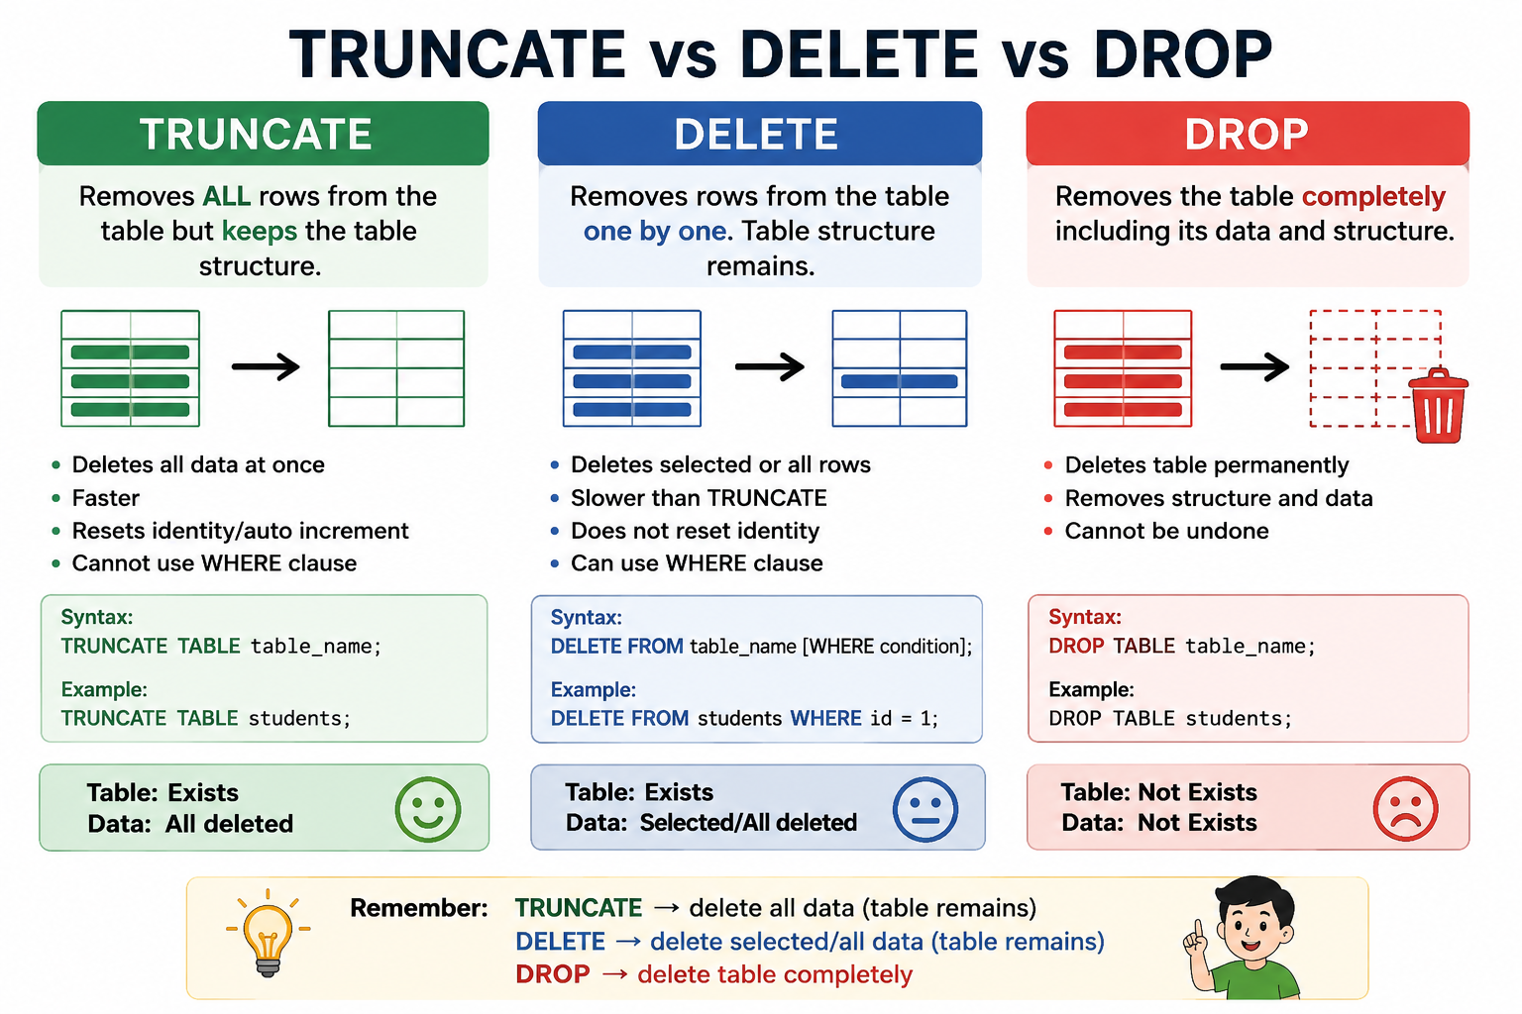

3 .DQL - | Data Query Language -
1 . SELECT Command :-
The SELECT command is the most important DQL command.
It is used to retrieve data from a table.
Syntax –
SELECT column_name FROM table_name;
Example –
SELECT name FROM employees;
2 . SELECT All Columns :-
To display all columns from a table, use *.
Syntax –
SELECT * FROM table_name;
Example –
SELECT * FROM employees;
3. SELECT Specific Columns :-
You can select only the columns you need.
Syntax –
SELECT column1, column2, column3 FROM table_name;
Example –
SELECT name, department, salary FROM employees;

# Exit from MySQL – command -
exit;
quiet;
\q

4 .DCL - | Data Control Language –
DCL stands for Data Control Language.
DCL is used to control access and permissions of users in a database.
DCL decides what a database user is allowed to do.
Grant , Revoke
For example, a database administrator can give a user permission to:
- Read data
- Insert data
- Update data
- Delete data
- Create tables

1. CREATE USER -
The CREATE USER statement is used to create new MySQL user accounts.

Syntax : -
CREATE USER 'username'@'host' IDENTIFIED BY 'password';
select user from mysql.user;
select user();
Examples :-
Create user with access from localhost only
1 . CREATE USER 'nikhil'@'localhost' IDENTIFIED BY 'nikhil@123';

2 . CREATE USER 'admin'@'localhost' IDENTIFIED BY 'Admin@123';
3 . create user 'shubhangi' identified by 'shubhangi@123';

2. SET PASSWORD -
The SET PASSWORD statement is used to change user passwords.
Syntax :-
SET PASSWORD = 'new password@123';
Example :-
set password = 'shubhangi1525';
SET PASSWORD = 'nikhil@1525';
mysql -u root -p
Enter password: ********
exit
Old Password → nikhil@123
New Password → nikhil@1525

1. Show All MySQL Users –
Syntax –
SELECT User FROM mysql.user;
2. Check a Specific User –
SELECT User FROM mysql.user WHERE User = 'nikhil';
3. Check Current Logged-in User -
SELECT USER();
A . GRANT Command –
GRANT statement is used to provide access privileges to users on databases and tables.
Single table access -
Syntax –
GRANT privilege_name ON table_name TO 'username';
Example –
GRANT SELECT ON students TO 'rahul';
Mutiple table access –
MySQL Privilege Types:
- ALL PRIVILEGES: All privileges except GRANT OPTION
- SELECT: Read data from tables
- INSERT: Insert rows into tables
- UPDATE: Modify existing data
- DELETE: Delete rows from tables

1. GRANT SELECT –
SELECT allows a user to read data.
Syntax –
GRANT SELECT ON table_name TO 'username';
Example –
GRANT SELECT ON students TO 'rahul';
SELECT * FROM students;
2. GRANT INSERT -
INSERT allows a user to add new records.
Syntax –
GRANT INSERT ON table_name TO 'username’;
Example –
GRANT INSERT ON students TO 'rahul';
INSERT INTO students VALUES (101, 'Rahul', 20, 'Python');

3. GRANT UPDATE -
UPDATE allows a user to modify existing records.
Syntax –
GRANT UPDATE ON table_name TO 'username';
Example -
GRANT UPDATE ON students TO 'rahul';
UPDATE students SET age = 21 WHERE student_id = 101;
4. GRANT DELETE -
DELETE allows a user to remove records.
Syntax :-
GRANT DELETE ON table_name TO 'rahul';
Example :-
GRANT DELETE ON students TO 'rahul';
DELETE FROM students WHERE student_id = 101;

5. Grant Multiple Privileges -
You can give multiple privileges in a single GRANT statement.
Syntax :-
GRANT privilege1, privilege2, privilege3 ON table_name TO 'username';
Example :-
GRANT SELECT, INSERT, UPDATE ON students TO 'rahul';
- Read records → SELECT
- Add records → INSERT
- Modify records → UPDATE
But he has not been granted DELETE through this statement.
CREATE TABLE customer (
customer_id INT,
customer_name VARCHAR(50),
city VARCHAR(50)
);
CREATE TABLE feedback (
feedback_id INT,
customer_id INT,
message VARCHAR(100)
);

CREATE USER 'rahul'@'localhost'
IDENTIFIED BY 'rahul123';

Give access to multiple tables
GRANT SELECT, INSERT
ON practice_db.customer TO 'rahul'@'localhost';

GRANT SELECT, INSERT
ON practice_db.feedback TO 'rahul'@'localhost';

Can we write both tables in ONE GRANT statement?
No. MySQL's normal GRANT syntax does not allow:
GRANT SELECT, INSERT
ON practice_db.customer, practice_db.feedback
TO 'rahul'@'localhost';

Instead, use separate GRANT statements:
GRANT SELECT, INSERT
ON practice_db.customer TO 'rahul'@'localhost';

GRANT SELECT, INSERT
ON practice_db.feedback TO 'rahul'@'localhost';

Another easy method: Give access to ALL tables
If you want Rahul to have SELECT and INSERT access to every table in practice_db:

GRANT SELECT, INSERT
ON practice_db.*
TO 'rahul'@'localhost';
Here:
- practice_db.customer → only customer table
- practice_db.feedback → only feedback table
- practice_db.* → all tables in practice_db
Check Rahul's privileges
SHOW GRANTS FOR 'rahul'@'localhost';
Student note:
For specific multiple tables, use multiple GRANT statements. For all tables in a database, use database_name.*.

2. REVOKE Command –

The REVOKE command is used to remove permissions from a MySQL user.

Syntax –
REVOKE privilege ON table_name FROM 'username';
Example –
- Select -
REVOKE SELECT ON students FROM 'rahul'';
- All -
GRANT SELECT, INSERT, UPDATE, DELETE ON students TO 'rahul';

5. TCL – Transaction Control Language –
TCL stands for Transaction Control Language.
What is a Transaction –

A transaction is a collection of SQL operations performed as a single logical unit.

- Transaction control commands are used with DML commands like INSERT, UPDATE, DELETE.

- Create table/drop table commands are auto commit.

- TCL commands are used to manage transactions in a database.
Commit, Rollback, Savepoint

Commit – to save transaction
Rollback – to roll back the transaction
Savepoint – creates points within the groups of transactions.

START TRANSACTION / BEGIN :-
Starts a new transaction.
Syntax –
Start transaction;
Or
Begin;
Example –
Account table -
account_id | name | balance
101 | Rahul | 10000
102 | Priya | 5000

Rahul wants to transfer ₹2,000 to Priya.

UPDATE account
SET balance = balance - 2000
WHERE account_id = 101;

UPDATE account
SET balance = balance + 2000
WHERE account_id = 102;

Both statements together form one transaction.
If both are successful:
COMMIT;
If there is an error:
ROLLBACK;
TCL Command | Purpose

COMMIT | - Permanently saves changes

ROLLBACK | - Cancels changes made in the current transaction

SAVEPOINT | - Creates a temporary point inside a transaction

ROLLBACK TO SAVEPOINT | - Goes back to a particular savepoint

RELEASE SAVEPOINT | - Removes a savepoint

- COMMIT Command –
COMMIT is used to permanently save the changes made during a transaction.
Once the transaction is committed, the changes cannot normally be undone using ROLLBACK.
Syntax –
COMMIT;
Example –
- CREATE TABLE customer (customer_id INT, customer_name VARCHAR(50),balance DECIMAL(10,2));
START TRANSACTION;
INSERT INTO customer
VALUES (101, 'Rahul', 5000);
COMMIT;

Explanation
- Transaction starts.
- Rahul's record is inserted.
- COMMIT permanently saves the record.

Example 2 — UPDATE
START TRANSACTION;
UPDATE customer
SET balance = 8000
WHERE customer_id = 101;
COMMIT;

Explanation -
The balance of customer 101 is changed to 8000 and COMMIT permanently saves the change.
Remember –
COMMIT = SAVE PERMANENTLY

After COMMIT, the inserted record becomes permanently saved.
Important point
Once a transaction has been committed, you generally cannot use ROLLBACK to undo those already committed changes.

Simple meaning –
START TRANSACTION
↓
Make changes
↓
COMMIT
↓
Save changes permanently

2 .ROLLBACK Command –

ROLLBACK is used to undo changes made during the current transaction.
Think of ROLLBACK as an Undo button.
It is useful when an error occurs or when we decide not to save the changes.
If you make changes to a table but then decide "I don't want these changes", you can use ROLLBACK to cancel them.

Syntax –
ROLLBACK;

Example –
1 .INSERT –
START TRANSACTION;
INSERT INTO customer
VALUES (102, 'Priya', 7000);
ROLLBACK;
Explanation
The record for Priya is inserted temporarily, but ROLLBACK cancels the insertion.

Example 2 . DELETE –
START TRANSACTION;

DELETE FROM customer
WHERE customer_id = 102;

ROLLBACK;
Explanation -
The customer record is deleted during the transaction, but ROLLBACK cancels the deletion.
Remember –
ROLLBACK = UNDO CHANGES
Before-
student_id | name | age | course
101 | Rahul | 20 | Python
102 | Priya | 21 | Java

After -
student_id | name | age | course
101 | Rahul | 20 | Python
102 | Priya | 21 | Java

ROLLBACK = Undo

START TRANSACTION
↓
Make Changes
↓
"I don't want them"
↓
ROLLBACK
↓
Changes are undone

- SAVEPOINT Command –
SAVEPOINT is a TCL (Transaction Control Language) command used to create a checkpoint inside a transaction.

SAVEPOINT creates a checkpoint inside a transaction. It does not undo any changes by itself.

If needed, we can use ROLLBACK TO SAVEPOINT to undo changes made after that checkpoint.

Syntax –
SAVEPOINT savepoint_name;
SAVEPOINT s1;
Example –
Example 1 . –
START TRANSACTION;
INSERT INTO customer
VALUES (103, 'Amit', 6000);
SAVEPOINT sp1;
INSERT INTO customer
VALUES (104, 'Sneha', 8000);
COMMIT;

Explanation -
Here, sp1 is created after inserting Amit.
The transaction can later return to sp1 if required.

Example 2 — Multiple Savepoints –
START TRANSACTION;
INSERT INTO customer
VALUES (105, 'Riya', 5000);
SAVEPOINT sp1;
INSERT INTO customer
VALUES (106, 'Neha', 7000);
SAVEPOINT sp2;

INSERT INTO customer
VALUES (107, 'Kiran', 9000);

Here we have:
START TRANSACTION
↓
Insert Riya
↓
SAVEPOINT sp1
↓
Insert Neha
↓
SAVEPOINT sp2
↓
Insert Kiran
There are two checkpoints: sp1 and sp2.
Remember –
SAVEPOINT = CHECKPOINT

4 . ROLLBACK TO SAVEPOINT –
ROLLBACK TO SAVEPOINT is used to undo the changes made after a particular savepoint.
It does not cancel the entire transaction.
Syntax –
ROLLBACK TO SAVEPOINT savepoint_name;

Example 1 –
START TRANSACTION;
INSERT INTO customerVALUES (108, 'Asha', 4000);
SAVEPOINT sp1;
INSERT INTO customerVALUES (109, 'Pooja', 5000);
ROLLBACK TO SAVEPOINT sp1;
COMMIT;

Explanation -
After sp1, Pooja's record was inserted.
When we execute:
ROLLBACK TO SAVEPOINT sp1;

Pooja's insertion is undone.
Asha's insertion remains.

Then:
COMMIT;
saves Asha's record.
Result –
Asha → Saved
Pooja → Undone

Example 2 — UPDATE –
START TRANSACTION;

UPDATE customer
SET balance = 6000
WHERE customer_id = 101;
SAVEPOINT sp1;

UPDATE customer
SET balance = 9000
WHERE customer_id = 102;
ROLLBACK TO SAVEPOINT sp1;

COMMIT;
Explanation
The update for customer 102 is undone.
The update for customer 101 remains.

Result –
Customer 101 → Change remains
Customer 102 → Change undone
Remember –
ROLLBACK TO SAVEPOINT
↓
Undo changes AFTER the savepoint

RELEASE SAVEPOINT –
RELEASE SAVEPOINT is used to remove a savepoint that is no longer required.

Syntax –
RELEASE SAVEPOINT savepoint_name;

Example 1 –
START TRANSACTION;
INSERT INTO customer VALUES (110, 'Kavita', 6000);

SAVEPOINT sp1;

INSERT INTO customerVALUES (111, 'Meena', 7000);

RELEASE SAVEPOINT sp1;
COMMIT;

Explanation –
sp1 is created and later removed using:

RELEASE SAVEPOINT sp1;
The transaction itself is not committed by RELEASE SAVEPOINT.

The changes are saved only when:
COMMIT;
is executed.

Example 2 –
START TRANSACTION;

UPDATE customer
SET balance = 7500
WHERE customer_id = 101;

SAVEPOINT update_point;

UPDATE customer
SET balance = 8500
WHERE customer_id = 102;

RELEASE SAVEPOINT update_point;

COMMIT;

SQL Clauses

— WHERE, GROUP BY, HAVING, FROM and ON

These clauses are used to select, filter, group, and combine data from one or more tables
- WHERE Clause –
The WHERE clause is used to filter individual rows from a table.
Only rows that satisfy the specified condition are returned.
Syntax –
SELECT column1, column2
FROM table_name
WHERE condition;

CREATE TABLE employees (employee_id INT,name VARCHAR(50),department VARCHAR(30), salary DECIMAL(10,2));

INSERT INTO employees
(employee_id, name, department, salary)
VALUES
(101, 'Rahul', 'IT', 50000),
(102, 'Priya', 'HR', 40000),
(103, 'Amit', 'IT', 60000),
(104, 'Sneha', 'Sales', 45000);

Example 1 — Find employees from IT department
employee_id | name | department | salary
101 | Rahul | IT | 50000
102 | Priya | HR | 40000
103 | Amit | IT | 60000
104 | Sneha | Sales | 45000

SELECT * FROM employees
WHERE department = 'IT';
Output –
employee_id | name | department | salary
101 | Rahul | IT | 50000
103 | Amit | IT | 60000

Example 2 — Find employees earning more than 50,000
SELECT name, salary
FROM employees
WHERE salary > 50000;

Output –
name | salary
Amit | 60000

Common operators with WHERE –
Operator | Meaning | Example
= | Equal to | salary = 50000
> | Greater than | salary > 50000
< | Less than | salary < 50000
>= | Greater than or equal | salary >= 50000
<= | Less than or equal | salary <= 50000
<> | Not equal | department <> 'HR'
AND | Both conditions true | salary > 40000 AND department = 'IT'
OR | Either condition true | department = 'IT' OR department = 'HR'

Remember –
WHERE filters rows before grouping.
Easy trick for students –
= → Same
> → More than
< → Less than
>= → More than or same
<= → Less than or same
<> → Not same
AND → Both
OR → Any one

Full query examples -
- Equal to –
SELECT * FROM employees
WHERE department = 'IT';

- Greater than –
SELECT * FROM employees
WHERE salary > 50000;

- Less than –
SELECT *FROM employees
WHERE salary < 50000;

- Greater than or equal –
SELECT * FROM employees
WHERE salary >= 50000;

- Less than or equal –
SELECT * FROM employees
WHERE salary <= 40000;

- Not equal -
SELECT * FROM employees
WHERE department <> 'HR';

- AND –
SELECT * FROM employees
WHERE department = 'IT'
AND salary > 50000;

- OR –
SELECT *FROM employees
WHERE department = 'IT'
OR department = 'HR';

Student Practice Task — WHERE Clause
customer_id | customer_name | age | city | gender | purchase_amount
101 | Rahul | 25 | Pune | Male | 15000
102 | Priya | 30 | Mumbai | Female | 25000
103 | Amit | 35 | Pune | Male | 40000
104 | Sneha | 28 | Delhi | Female | 18000
105 | Kiran | 40 | Mumbai | Male | 55000
106 | Neha | 22 | Pune | Female | 12000
107 | Rohan | 32 | Delhi | Male | 30000
108 | Pooja | 27 | Mumbai | Female | 22000
109 | Akash | 45 | Pune | Male | 65000
110 | Anita | 24 | Delhi | Female | 14000

Instruction: Write and execute the SQL query for each question.
Q1 . Display customers who are from Pune.
Q2. Display customers whose gender is Female.
Q3. Display customers whose purchase amount is greater than 30,000.
Q4. Display customers whose age is greater than 30.
Q5. Display customers whose purchase amount is less than 20,000.
Q6. Display customers whose age is less than 25.
Q7. Display customers whose purchase amount is 30,000 or more.
Q8. Display customers whose age is 30 or more.
Q9. Display customers whose purchase amount is 20,000 or less.
Q10. Display customers whose age is 25 or less.
Q11. Display customers who are not from Mumbai.
Q12. Display customers whose gender is not Male.
Q13. Display customers who are from Pune and have a purchase amount greater than 30,000.
Q14. Display Male customers whose age is greater than 30.
Q15. Display customers from Mumbai whose purchase amount is greater than 20,000.
Q16. Display customers who are from Pune or Mumbai.
Q17. Display customers who are Male or Female.
Q18. Display customers whose purchase amount is less than 15,000 or greater than 50,000.
Q19. Display Male customers from Pune.
Q20. Display customers who are from Pune or Delhi and whose purchase amount is greater than 20,000.
Q21. Display customers from Mumbai whose age is greater than 25 and purchase amount is greater than 20,000.
Q22. Display customers from Pune or Mumbai whose age is 30 or more.

Answers
Q1. SELECT * FROM customer WHERE city = 'Pune';
Q2. SELECT * FROM customer WHERE gender = 'Female';
Q3. SELECT * FROM customer WHERE purchase_amount > 30000;
Q4. SELECT * FROM customer WHERE age > 30;
Q5. SELECT * FROM customer WHERE purchase_amount < 20000;
Q6. SELECT * FROM customer WHERE age < 25;
Q7. SELECT * FROM customer WHERE purchase_amount >= 30000;
Q8. SELECT * FROM customer WHERE age >= 30;
Q9. SELECT * FROM customer WHERE purchase_amount <= 20000;
Q10. SELECT * FROM customer WHERE age <= 25;
Q11. SELECT * FROM customer WHERE city <> 'Mumbai';
Q12. SELECT * FROM customer WHERE gender <> 'Male';
Q13. SELECT * FROM customer WHERE city = 'Pune' AND
purchase_amount > 30000;
Q14. SELECT * FROM customer WHERE gender = 'Male' AND age > 30;
Q15. SELECT * FROM customer WHERE city = 'Mumbai' AND
purchase_amount > 20000;
Q16. SELECT * FROM customer WHERE city = 'Pune' OR city = 'Mumbai';
Q17. SELECT * FROM customer WHERE gender = 'Male' OR gender = 'Female';
Q18. SELECT * FROM customer WHERE purchase_amount < 15000 OR purchase_amount > 50000;
Q19. SELECT * FROM customer WHERE gender = 'Male' AND city = 'Pune';
Q20. SELECT * FROM customer WHERE (city = 'Pune' OR city = 'Delhi') AND purchase_amount > 20000;
Q21. SELECT * FROM customer WHERE city = 'Mumbai' AND age > 25 AND purchase_amount > 20000;
Q22. SELECT * FROM customer WHERE (city = 'Pune' OR city = 'Mumbai') AND age >= 30;

1. LIKE Operator -
The LIKE operator is used to search for a specific pattern in text/string values.
It is commonly used with the WHERE clause.
Syntax -
SELECT column_name FROM table_name
WHERE column_name LIKE 'pattern';
Wildcards used with LIKE -
Wildcard | Meaning | Example
% | Represents zero or more characters | 'R%'
_ | Represents exactly one character | 'R_hul'

Example 1 — Name starts with R
SELECT *FROM employees
WHERE name LIKE 'R%';
Output –
employee_id | name | department | salary
101 | Rahul | IT | 50000

R%' means:
Name must start with R, followed by any number of characters.

Example 2 — Name ends with a –
SELECT * FROM employees
WHERE name LIKE '%a';
This searches for names ending with a.

Example 3 — Name contains i
SELECT * FROM employees
WHERE name LIKE '%i%';
%i% means the name can have any characters before and after i.
Easy way to remember
'R%' → Starts with R
'%a' → Ends with a
'%i%' → Contains i
'_a%' → Second character is a

2. BETWEEN Operator -
The BETWEEN operator is used to select values within a specified range.
It includes both the starting and ending values.
Syntax –
SELECT column_name FROM table_name
WHERE column_name BETWEEN value1 AND value2;

Example 1 — Salary between 40,000 and 50,000
SELECT * FROM employees
WHERE salary BETWEEN 40000 AND 50000;
Output -
employee_id | name | department | salary
101 | Rahul | IT | 50000
102 | Priya | HR | 40000
104 | Sneha | Sales | 45000

Notice that 40,000 and 50,000 are included.
Example 2 — Employee ID between 102 and 104
SELECT * FROM employees
WHERE employee_id BETWEEN 102 AND 104;
Output -
employee_id | name | department | salary
102 | Priya | HR | 40000
103 | Amit | IT | 60000
104 | Sneha | Sales | 45000

3. IN Operator -
The IN operator is used to check whether a value matches any value in a list.
It is useful when we have multiple possible values.
Syntax –
SELECT column_name FROM table_name
WHERE column_name IN (value1, value2, value3);
Example 1 — Employees from IT or HR
Without IN:
SELECT * FROM employees
WHERE department = 'IT'
OR department = 'HR'

Using IN:
SELECT * FROM employees
WHERE department IN ('IT', 'HR');
Output -

employee_id | name | department | salary
101 | Rahul | IT | 50000
102 | Priya | HR | 40000
103 | Amit | IT | 60000

Example 2 — Find employees with selected salaries
SELECT *FROM employees
WHERE salary IN (40000, 50000, 60000);
This returns employees whose salary is 40,000, 50,000, or 60,000.

4. NULL -
What is NULL?
NULL means no value / missing value / unknown value.
It is important to understand:
NULL is not equal to 0.
Also:
NULL is not an empty string ('').
Example:
employee_id | name | department | salary
101 | Rahul | IT | 50000
102 | Priya | HR | NULL
103 | Amit | IT | 60000

Priya's salary is NULL, which means her salary value is missing or unknown.
5. IS NULL
To find records containing NULL, use IS NULL.
Syntax –
SELECT * FROM table_name
WHERE column_name IS NULL;
Example –
SELECT * FROM employees
WHERE salary IS NULL;
This displays employees whose salary has no value.
6. IS NOT NULL
To find records that do have a value, use IS NOT NULL.
Syntax –
SELECT * FROM table_name
WHERE column_name IS NOT NULL;
Example -
SELECT * FROM employees
WHERE salary IS NOT NULL;
This displays employees whose salary is available.
7. Important — Do NOT use = NULL
❌ Incorrect:
SELECT *FROM employees
WHERE salary = NULL;

✅ Correct:
SELECT *FROM employees
WHERE salary IS NULL;

LIKE vs BETWEEN vs IN vs NULL –
Operator/Condition | Used For | Example
LIKE | Pattern matching | name LIKE 'R%'
BETWEEN | Range of values | salary BETWEEN 40000 AND 50000
IN | Matching multiple values | department IN ('IT','HR')
IS NULL | Finding missing values | salary IS NULL
IS NOT NULL | Finding available values | salary IS NOT NULL

GROUP BY Clause in MySQL -
The GROUP BY clause is used to combine rows having the same value into groups
Syntax –
SELECT column_name FROM table_name
GROUP BY column_name;
Example -
Suppose we have an employees table:
employee_id | name | department
101 | Rahul | IT
102 | Priya | HR
103 | Amit | IT
104 | Sneha | Sales
105 | Neha | HR
106 | Raj | IT

Now we want to display employees grouped by their department.
SELECT department
FROM employees
GROUP BY department;

Output –
Department
HR
IT
Sales

here, MySQL finds the same department values and displays each department only once.
So:
- IT → one group
- HR → one group
- Sales → one group

Grouping by Multiple Columns -
You can group records using more than one column.
Syntax –
SELECT column1, column2 FROM table_name
GROUP BY column1, column2;
Example –
SELECT department, city FROM employees
GROUP BY department, city;

name | department | city
Rahul | IT | Pune
Amit | IT | Mumbai
Priya | HR | Pune
Neha | HR | Pune
Raj | IT | Pune

Output –
department | city
HR | Pune
IT | Mumbai
IT | Pune

Here, MySQL creates groups based on the combination of department + city.
For example:
IT + Pune
IT + Mumbai
HR + Pune

WHERE with GROUP BY –
You can use WHERE before GROUP BY.
Example –
SELECT department
FROM employees
WHERE city = 'Pune'
GROUP BY department;

How it works
First, WHERE selects only employees from Pune.
Then, GROUP BY groups those employees by department.

Order of clauses –
SELECT – FROM – WHERE - GROUP BY - ORDER BY
Example –
SELECT city FROM customer WHERE age >= 18 GROUP BY city;
Meaning:
- Select customers whose age is 18 or more.
- Group them according to city.
- Display each city once

ORDER BY –
What is ORDER BY?
The ORDER BY clause is used to sort the records in a table.
You can sort data:
- In ascending order → ASC
- In descending order → DESC
Syntax –
SELECT column1, column2, ...
FROM table_name
ORDER BY column_name ASC;

SELECT column1, column2, ...
FROM table_name
ORDER BY column_name DESC;
Note: ASC is the default sorting order, so writing ASC is optional.
Example -
Suppose we have an employees table:

employee_id | name | department | salary
101 | Rahul | IT | 50000
102 | Priya | HR | 40000
103 | Amit | IT | 60000
104 | Sneha | Sales | 45000
105 | Neha | HR | 55000

1. Sort in Ascending Order -
Ascending means small to large or A to Z.
SELECT * FROM employees ORDER BY salary ASC;

Output –
employee_id | name | department | salary
102 | Priya | HR | 40000
104 | Sneha | Sales | 45000
101 | Rahul | IT | 50000
105 | Neha | HR | 55000
103 | Amit | IT | 60000

Here, salary is arranged from lowest to highest.
You can also write:
SELECT * FROM employees ORDER BY salary;
This gives the same result because ASC is the default.

2. Sort in Descending Order -
Descending means large to small or Z to A.
Example -
SELECT * FROM employees
ORDER BY salary DESC;
Output –

employee_id | name | department | salary
103 | Amit | IT | 60000
105 | Neha | HR | 55000
101 | Rahul | IT | 50000
104 | Sneha | Sales | 45000
102 | Priya | HR | 40000

Here, salary is arranged from highest to lowest.
3. ORDER BY with Text -
You can sort text columns alphabetically.
SELECT * FROM employees
ORDER BY name ASC;
Output –
employee_id | name | department | salary
103 | Amit | IT | 60000
105 | Neha | HR | 55000
102 | Priya | HR | 40000
101 | Rahul | IT | 50000
104 | Sneha | Sales | 45000

Names are arranged from A to Z.
For reverse alphabetical order:
SELECT * FROM employees
ORDER BY name DESC;

4. ORDER BY Multiple Columns -
You can sort using more than one column.
Syntax –
SELECT * FROM table_name
ORDER BY column1 ASC, column2 DESC;

Example –
SELECT * FROM employees
ORDER BY department ASC, salary DESC;

This means:
- Sort departments from A to Z.
- Within each department, sort salary from highest to lowest.
Result –

employee_id | name | department | salary
105 | Neha | HR | 55000
102 | Priya | HR | 40000
103 | Amit | IT | 60000
101 | Rahul | IT | 50000
104 | Sneha | Sales | 45000

5. ORDER BY with WHERE -
WHERE filters the records first, and ORDER BY sorts the result.
SELECT *FROM employees
WHERE department = 'IT'
ORDER BY salary DESC;

Output –

employee_id | name | department | salary
103 | Amit | IT | 60000
101 | Rahul | IT | 50000

Meaning:
First find employees from the IT department, then arrange them by salary from highest to lowest.

6. ORDER BY with GROUP BY -
GROUP BY creates groups, and ORDER BY can sort those groups.
department
HR
IT
Sales
Output –

Order of SQL Clauses -
A simple way to remember the order is:
SELECT – FROM – WHERE - GROUP BY – HAVING - ORDER BY – LIMIT

Alias in MySQL
Alias in MySQL
An Alias is a temporary name given to a table or column to make SQL queries easier to read and understand.
Alias does not change the actual column or table name in the database.
There are two main types:
- Column Alias
- Table Alias
- Column Alias -
A column alias gives a temporary name to a column in the output.
The AS keyword is used to create an alias.
Syntax –
SELECT column_name AS alias_name FROM table_name;
Example –
SELECT student_name AS name FROM student;
2 . Table Alias –
A table alias gives a temporary short name to a table.
Syntax –
SELECT alias.column_name
FROM table_name AS alias;

Example –
SELECT s.student_name, s.marks
FROM student AS s;
Here –
student → actual table name
s → table alias
Aggregate Functions in SQL –
An aggregate function is a SQL function that performs a calculation on multiple rows and returns one result.
For example, if a table has the salaries of 5 employees, we can use an aggregate function to find:
- Total salary
- Average salary
- Highest salary
- Lowest salary
- Number of employees

Common Aggregate Functions –
Function | Purpose
COUNT() | Counts rows/values
SUM() | Calculates total
AVG() | Calculates average
MAX() | Finds highest value
MIN() | Finds lowest value

1. COUNT() -
COUNT() is used to count the number of rows.
Syntax –
SELECT COUNT(column_name)
FROM table_name;

Example –
SELECT COUNT(student_id) AS total_students
FROM student;
Output –
total_students
5
To count all rows:
SELECT COUNT(*) AS total_students
FROM student;
2. SUM() -
SUM() is used to calculate the total of a numeric column.
Syntax –
SELECT SUM(column_name) FROM table_name;
Example –
student_id | student_name | marks
101 | Rahul | 75
102 | Priya | 85
103 | Amit | 65
104 | Sneha | 90
105 | Neha | 80
SELECT SUM(marks) AS total_marks FROM student;
total_marks
395
Output –

3. AVG()
AVG() is used to calculate the average value.
Syntax –
SELECT AVG(column_name) FROM table_name;
Example –
SELECT AVG(marks) AS average_marks FROM student;
average_marks
79.0000
Output –

The calculation is - (75 + 85 + 65 + 90 + 80) / 5 = 79

4. MAX() -
MAX() is used to find the highest value in a column.
Syntax –
SELECT MAX(column_name) FROM table_name;
Example -
SELECT MAX(marks) AS highest_marks FROM student;
Output –
highest_marks
90

5. MIN()
MIN() is used to find the lowest value in a column.
Syntax –
SELECT MIN(column_name) FROM table_name;
Example –
SELECT MIN(marks) AS lowest_marks FROM student;
Output –
lowest_marks
65

Using Multiple Aggregate Functions Together
We can use multiple aggregate functions in one SELECT statement.

SELECT
COUNT(*) AS total_students,
SUM(marks) AS total_marks,
AVG(marks) AS average_marks,
MAX(marks) AS highest_marks,
MIN(marks) AS lowest_marks
FROM student;
Aggregate Functions with GROUP BY
Aggregate functions are commonly used with GROUP BY when we want separate results for each group.
For example, if the student table contains a city column:

1 . SELECT city, COUNT(*) AS total_students FROM student GROUP BY city;
This gives the number of students from each city.

2 . SELECT city, AVG(marks) AS average_marks FROM student GROUP BY city;
This gives the average marks for each city.
Important –
Aggregate functions generally produce one result for the entire selected data. When combined with GROUP BY, they produce one result for each group.
Rule 1: Columns in SELECT should be grouped or aggregated -
If a column is written in SELECT and is not inside an aggregate function, it should normally appear in GROUP BY.
SELECT city, COUNT(*) FROM student GROUP BY city;
Here:
- city → in GROUP BY
- COUNT(*) → aggregate function

Rule 2: GROUP BY comes after WHERE –
SELECT FROM WHERE GROUP BY HAVING ORDER BY
Example –
SELECT city, AVG(marks) AS average_marks FROM student
WHERE marks >= 60GROUP BY city;
Here:
- FROM → gets data from student
- WHERE → selects students with marks ≥ 60
- GROUP BY → groups them by city
- AVG() → calculates average for each city

Rule 3: GROUP BY is used to create groups
Example –
SELECT city FROM student GROUP BY city;
city
Pune
Mumbai
Output –

It removes repeated city values and returns one row for each group.

